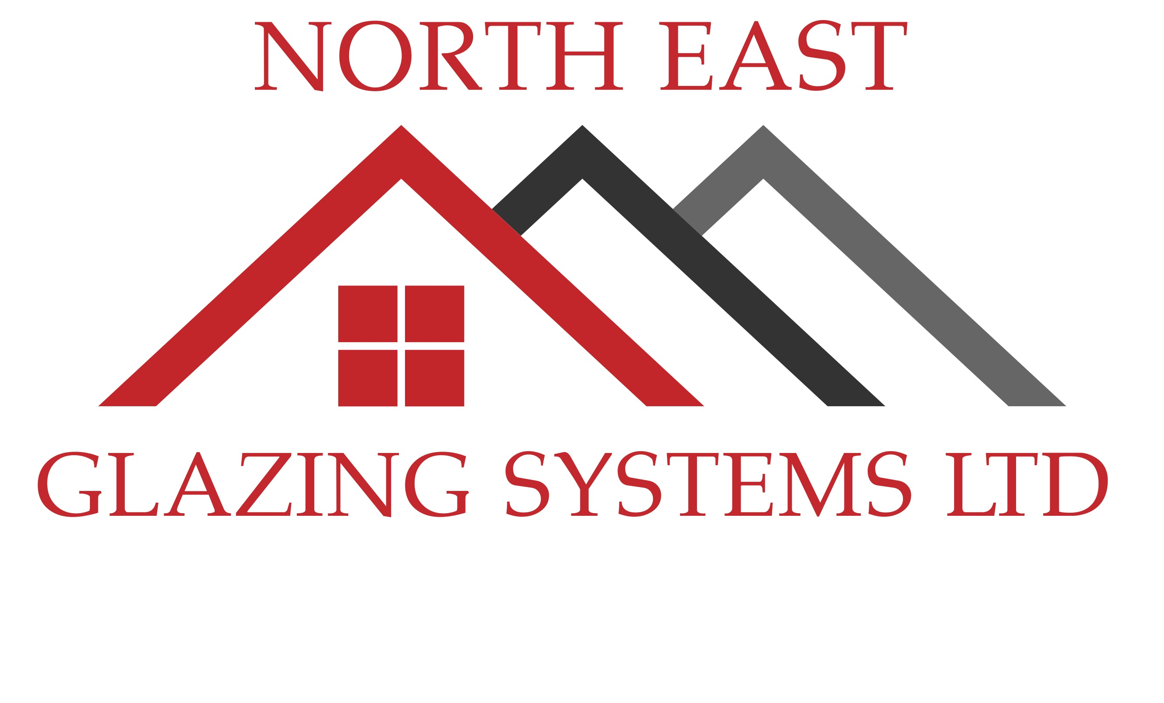
1 Sandfield Road, North Shields, Tyne and Wear, NE30 3LY
www.neglazingsystems.ltd 0800 246 1500 info@neglazingsystems.ltd
Anti-Burglary Guarantee
Your recent installation by North East Glazing Systems Ltd is covered by our unique anti-burglary guarantee. This guarantee covers your new installation against break-in through failure of the window and door hardware for 10 years from the date of installation. In the unlikely event of a break-in through failure of the hardware, North East Glazing Systems Ltd guarantee
- To temporarily secure the break in on the same day that it is reported to us.
- To fully repair the product, free of charge.
- To fully replace the product if any damage has been sustained to it, free of charge.
As well as the benefits shown above you may also qualify for compensation from our hardware manufactures as shown below (third-party registration required).
- Maco Secure Plus - £1000 towards insurance excess payments.
- Ultion guarantee - £1000 compensation.
- Era 5 Star guarantee - £1000 towards insurance excess payments and £1000 compensation.
- Sweet/Lock-Lock hardware – Free replacement products in the event of pitting or corrosion.
In the unlikely event of a break in due to failure of the hardware, North East Glazing Systems Ltd will need to carry out an inspection of the break in as soon as the police have finished their report, we will also require the crime number from the break in and your insurance company details.
This guarantee does not cover against attempted burglary - Where an intruder was stopped from entering the property due to our high security products, it is deemed that the product has performed as expected. This guarantee does not cover against break-in due to breakage of glass. In either of these situations, the company will at its own discretion carry out any repairs required (including glass replacement) free of charge, as a good will gesture.
All lockable windows and doors always need to be kept locked, with the keys removed but in a safe place in case of emergency.
All products need to be kept maintained as per our maintenance instructions.

Page 1
To activate this guarantee, you must register your products online using the information shown below, within 14 days of installation.

Customer Name…………………………………………….……………………………………………………………………………………………………………………….
Installation Address…………………………………………………………………………………………………………………………………………………………………
………………………………………………………………………………………………………………Postcode…………………………………………………………………
Installation date………………………………………………………………………………………………………………………………………………………………………
Installer invoice number………………………………………………..Manufacturer Job number……………………………………………………………...
Installer Maco secure plus registration number - CNR-08561-F7J3T0
Products fitted with Maco locks | Quantity | System
Casement windows
Tilt and Turn windows
Single doors
Double doors
Other products

Products fitted with Era locks | Quantity | System
Windows
Doors
Other products

Doors fitted with Ultion Cylinders | Key code | Quantity

Doors fitted with Sweet hardware | Product | Quantity
Page 2
Step 1 – Third party registration
To register the third-party products and be eligible for the compensation shown above in the event of a break-in, go to www.neglazingsystems.ltd and go to the guarantee section.
This guarantee requires the following third-party registrations
Product to be registered | Tick
Maco secure plus
Ultion
Era 5-star guarantee
Sweet hardware

Step 2 – Company registration
To register this guarantee with North East Glazing Systems Ltd and be eligible for free repairs/replacement products in the event of a break-in, all that we require is for you to post a review of your recent installation (including a picture/pictures) to either our company Facebook page or our company Twitter page.
Facebook - @neglazingsystems.ltd
Twitter - @neglazing

Step 3 – Confirm registration
Once you have completed steps 1 and 2 as shown above, please email us at info@neglazingsystems.ltd to confirm that you have registered your products and left a review, and your guarantee will become active.

Thank you for your business.

Signed on behalf of North East Glazing Systems Ltd…………………………………………………………………………Date……………………………..

Page 3

