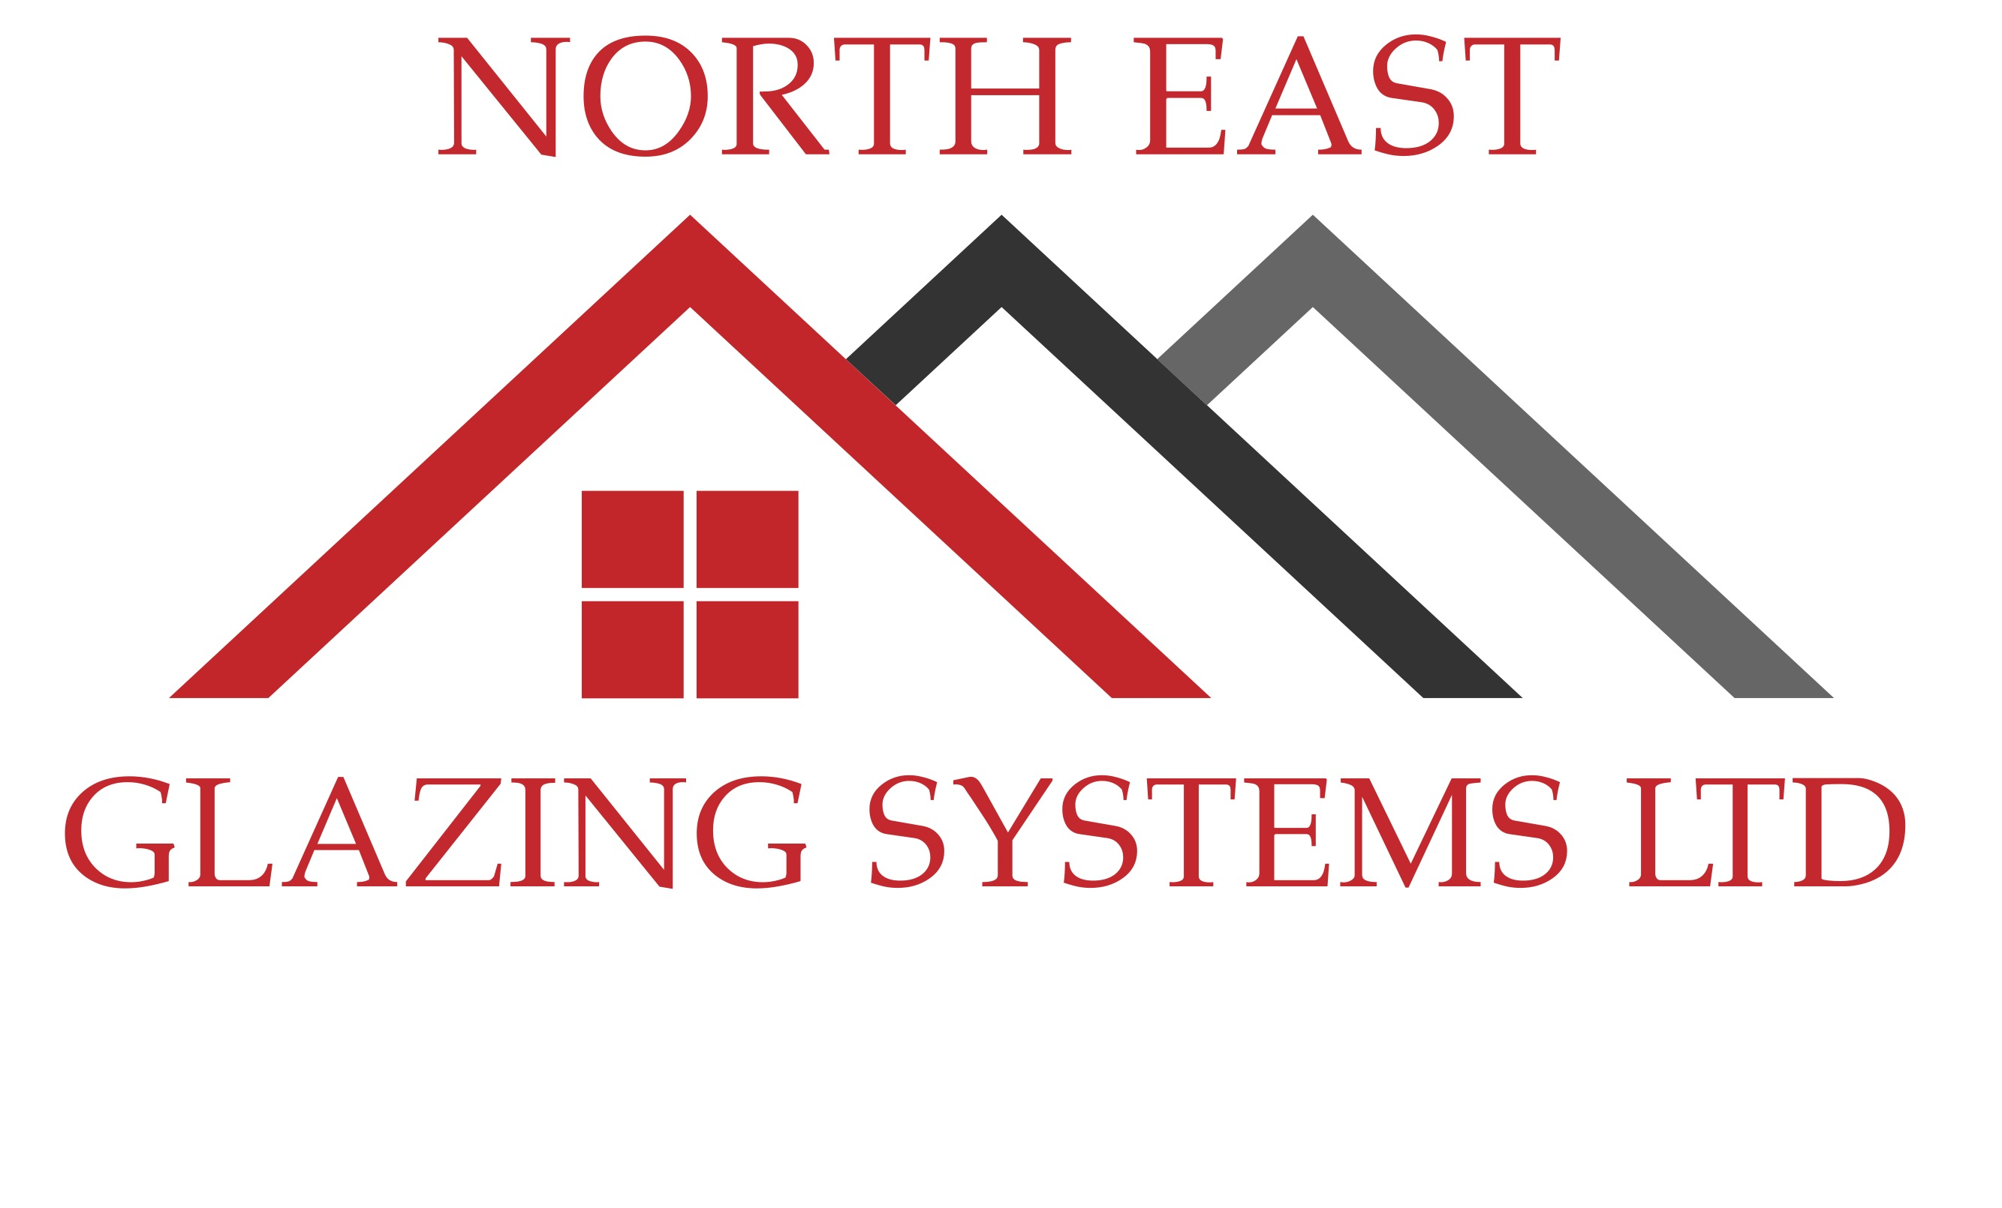
1 Sandfield Road, North Shields, Tyne and Wear, NE30 3LY
www.neglazingsystems.ltd 0800 246 1500 info@neglazingsystems.ltd
A-Rated - Guarantee
Your recent installation by North East Glazing Systems Ltd is covered by our unique A-Rated guarantee. This guarantee proves that your new installation has been designed, manufacture, and fitted, with the highest levels of security and energy efficiency in mind. Many modern window and door systems available nowadays are both very energy efficient and very secure, however one of the most important and often overlooked aspects is how these products are fitted.
North East Glazing Systems Ltd guarantee that the installation shown below has been designed, manufactured, and fitted to the highest possible standards of both energy efficiency and security.
Customer Name…………………………………………….……………………………………………………………………………………………………………………….
Installation Address…………………………………………………………………………………………………………………………………………………………………
………………………………………………………………………………………………………………Postcode…………………………………………………………………
Installation date………………………………………………………………………………………………………………………………………………………………………
Installer invoice number………………………………………………..Manufacturer Job number……………………………………………………………...
Product and Quantity
SBD Specification
SBD Certification
PAS 24 Specification
PAS 24 Certification
A-Rated Energy Rating
Energy Rated Fitting
Security Fitting

Secured by design specification – We guarantee that the products shown above have been manufactured to the high specification required to meet the ‘Secured by design’ standard.
Secured by design Certification – We guarantee that the products shown above have not only been manufactured to the high specification required to meet ‘Secured by design’ but have also been manufactured by a licenced ‘Secured by design’ manufacturer and therefore are fully certified as ‘Secured by design’.
PAS 24 Specification - We guarantee that the products shown above have been manufactured to the high specification required to meet the PAS 24:2016 security standard.
PAS 24 Certification - We guarantee that the products shown above have not only been manufactured to the high specification required to meet the PAS 24:2016 security standard but have also been manufactured by a licensed PAS 24 manufacturer and therefor are fully certified as being PAS 24:2016 compliant.
Energy rated fitting – We guarantee that we have fitted the above products to be as energy efficient as possible. All voids and gaps around the frame have been fully filled using either an expanding PU foam filler or an expanding tape filler, depending on specific site conditions. Both above methods fully seal the frame to the existing structure, not only making it completely weathertight, but also reducing movement, heat loss, and sound transmission.
Security fitting – We guarantee that we have fitted the above products to be as secure as possible. The product has been fixed in to the existing structure in the correct manor, using the correct amount of high strength proprietary fixings, which all penetrate the existing structure by 100mm. This means that the product can not easily be removed from the structure by force.

North East Glazing Systems Ltd guarantee to fully replace any product that has been forcibly removed during a break-in, due to failure of the fixing method of the product. Please note that in the unlikely event of a break in due to failure of the fixing method, North East Glazing Systems Ltd will need to carry out an inspection of the break in as soon as the police have finished their report, we will also require the crime number from the break in and your insurance company details. This guarantee lasts for 10 years from the date of the installation.

Signed on behalf of North East Glazing Systems Ltd……………………………………………………………………… Date……………………………….

For anymore information on the above product specifications, please visit our website www.neglazingsystems.ltd

