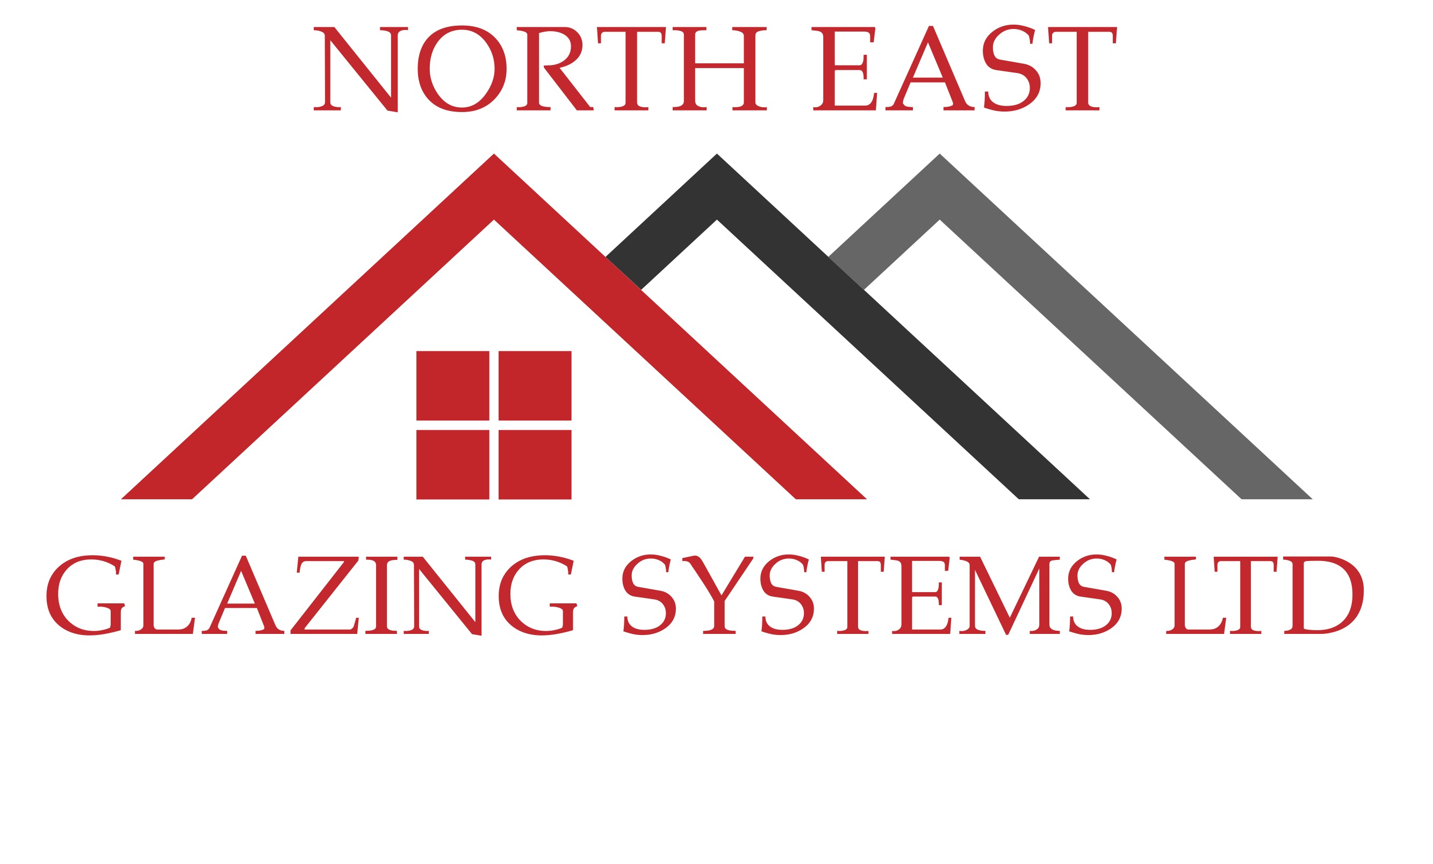
1 Sandfield Road, North Shields, Tyne and Wear, NE30 3LY
www.neglazingsystems.ltd 0800 246 1500 info@neglazingsystems.ltd
10 YEAR COMPANY GUARANTEE

Issued to:
Installation
address:

Installation date:

Product | Manufacturer | Reference | Material | Quantity | Supply / Fit

Guarantee Terms and Conditions

Should any fault appear in any window frame, door frame, or roof structure supplied and installed by us, because of defective materials or workmanship, North East Glazing Systems Ltd will at their own discretion, repair or replace the faulty materials free of all charges.

This guarantee is conditional to the products being adequately and properly maintained as per our ‘homeowner care guide’ as issued with this guarantee. If it is deemed after a visit from a company representative that the products have not been adequately and properly maintained, we will render the guarantee null and void, leaving any remedial work to be carried out at a pre-arranged fee, payable before any work commences.

If it is deemed after a visit from a company representative that the products have been subject to any wilful damage, abnormal working conditions, failure to follow instructions, misuse, alteration or unauthorised repair, improper maintenance, or negligence on the part of the customer or a third party, we will render the guarantee null and void, leaving any remedial work to be carried out at a pre-arranged fee, payable before any work commences.

This guarantee does not cover against - Minor imperfections in the glass, surface treatments to glass, and breakage of glass after the installation. Aluminium powder coatings have a manufactures guarantee of between 10 and 25 years, depending on the product, however they are only guaranteed when properly maintained as per the homeowner care guide.

No guarantee is given as to the elimination or reduction of condensation unless it is in-between the glass panes.

If the customer has not paid for the products in full by the date that the defect is notified to the company, then the company has no obligation to remedy the defect.

Notice of any claim under this guarantee must be made in writing to the company within fourteen days of the alleged defect becoming apparent.

This Guarantee is not transferable unless requested in writing to the company, and is subject to an administration fee, which will be advised by the company at the time of the request.

The customer will have the benefit of the manufacturers guarantee in respect of any materials, and can be obtained from the company.

Signed …………………………………………………………………….……………..Date……………………………………………………………………

